CS5551 Advanced Software Engineering

**Problem Set 3 (PS-3)**

**Deadline: March 20 (T)**

Submit a hard copy of your solutions to the instructor during the class

**Name**: Cameron L'Ecuyer

**Class ID:** 17

Our taxi mobile solution will maximize your revenue with ease by using our apps. We help you manage and maintain our advanced technology. You have time to grow and dominate your competitors. Attracting new and retaining regular customers has never been so easy. TaxiMobileSolutions is the solution you have been looking for. Within a few short clicks using our app, available drivers will be able to view and accept pickup requests through our app. Customers will know the vehicle type and driver that is coming to pick them up. With this innovative technology, you can seamlessly connect drivers to riders by using our apps. We help make cities more accessible for riders, while generating more revenue for drivers. TaxiMobileSolutions is available for your customers and drivers on both iOS and Android platforms. TaxiMobileSolutions will white-label the solution for your taxi company. In branding the solution for your company, the solution will have your company’s logo and name, not TaxiMobileSolutions. You also have the option to further customize our product, based on your unique needs. With our solution, you need not look any further, because our product includes everything that you need to operate your business smoothly, efficiently and profitably.

We have developed this technology in such a way that customers will happily avoid the typical inconveniences of:

* Calling a taxi service company and being put on hold.
* Waiting an extended period of time for service.
* Hailing a taxicab in unpleasant weather conditions.
* Riding with unknown drivers they might not be comfortable with.
* Fumbling around in a purse or wallet for payment and tips.

1. Draw a software architecture for TaxiMobileSolutsions.
2. Explain how a MVC pattern is applicable to your software architecture of “TaxiMobileSolutsions” application (Adroid and iOS platforms)
3. Draw a sequence diagram for Calling a taxi service company

Reference:

* AmazonEC2 software Architecture Diagram https://aws.amazon.com/architecture/
* MVC Architectural pattern https://developer.chrome.com/apps/app_frameworks

1.

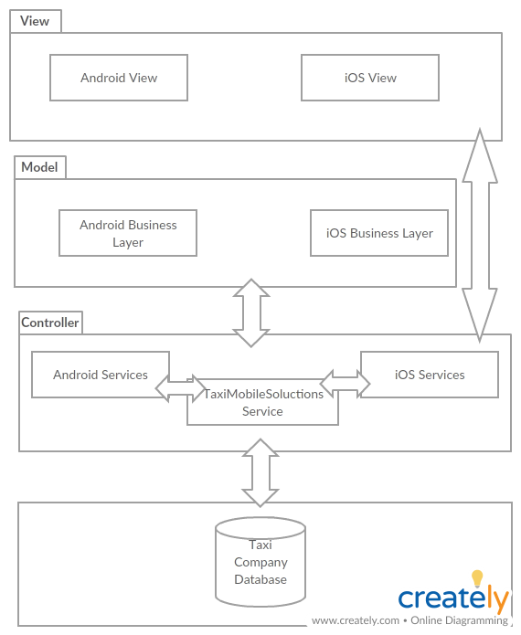

2.

A MVC pattern is useful because it forms a three-tiered architecture that mirrors the architecture used in the mobile platforms. The view is created and handled by the Android and iOS view controls, the model is handled by the Android and iOS logic systems, and the controller uses Android and iOS services, along side the service created by TaxiMobileSolutions. By using these services in the controller model it allows easy integration, or changing of services, without disrupting the entire application.

3.

